Input Mask
Pluggable widget for Mendix Studio Pro 10.24.17
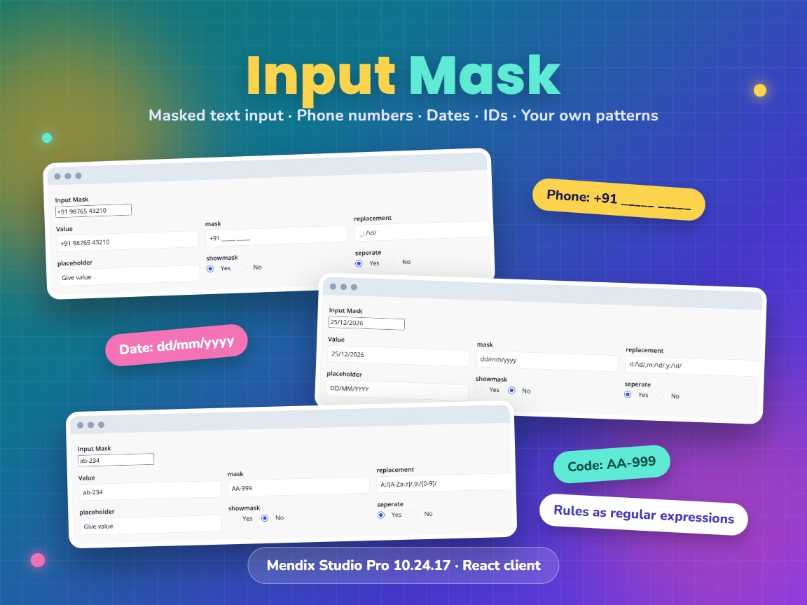
Item | Value
Widget version | 1.1.0
Studio Pro version | 10.24.17 (tested on 10.24.17.102810)
Widget ID | mendix.inputmask.InputMask
Widget package | mendix.InputMask.mpk (about 20 KB)
Platform | Web, React client (offline capable)
Mask library | @react-input/mask 2.0.4
Build tooling | @mendix/pluggable-widgets-tools 10.16.0
Source and downloads | github.com/bharathidas/InputMask

Contents

1. Overview
Input Mask is a text input that only accepts characters that fit a mask. The mask fixes the format of the text, for example +91 _____ _____ for a phone number or dd/mm/yyyy for a date. The fixed characters of the mask are added for the user; characters that do not fit are refused.
The mask, the rules for the mask characters, the placeholder and two options come from attributes of the context object, so they can differ per object and can change while the page is open. The text is stored in a String attribute exactly as it is shown in the input.
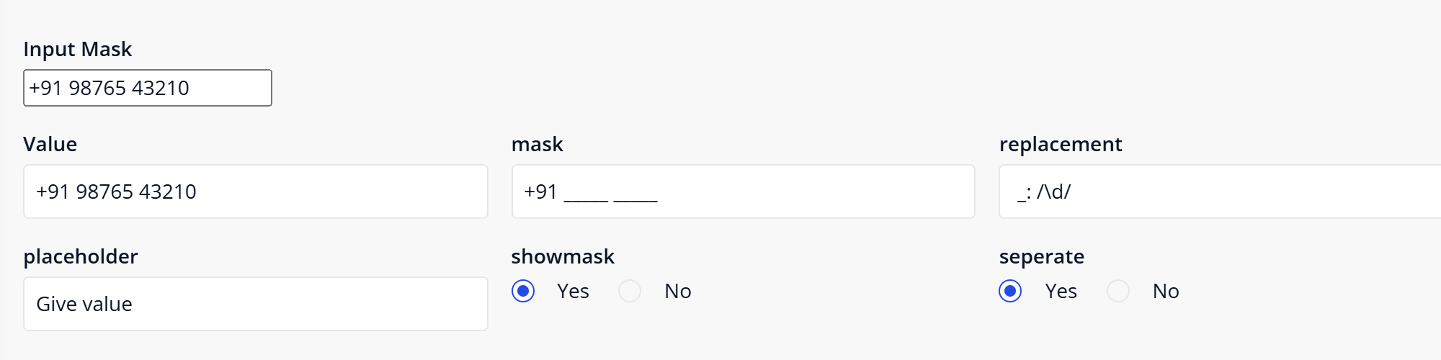
Figure 1. Phone number mask. The text boxes below the widget show the attributes that the widget uses.

Typical uses
- Phone numbers with a fixed country code and grouping
- Dates or times typed in a fixed format
- Codes with letters and digits, such as AB-123
- Any other text with a fixed length and fixed separators

2. What is new in version 1.1.0
- Rebuilt for Mendix Studio Pro 10.24.17 with @mendix/pluggable-widgets-tools 10.16.0, as a production build. The package is about 20 KB; version 1.0.0 was about 131 KB.
- The input can be cleared. In 1.0.0 an empty value was refused by a built-in "Value is required" rule without any message, so the attribute kept its old value.
- A regular expression may contain commas and colons, for example /[a,b:]/ or /\d{1,2}/. In 1.0.0 the rule was cut at the comma, and the widget could disappear from the page with an error.
- An invalid regular expression no longer breaks the widget. The rule is skipped; the other rules still work.
- The On click action runs when the user clicks the input. In 1.0.0 it never ran.
- A read-only value attribute gives a disabled input. In 1.0.0 the input stayed editable and typing caused an error. The input is also disabled while the attribute is loading.
- The validation message of the value attribute is shown below the input. In 1.0.0 it was not shown.
- The label is linked to the input, and the tab index from Studio Pro is applied.
- Studio Pro design mode shows a simple box with the name of the value attribute. In 1.0.0 it showed a real input filled with the attribute name.
- Clearer property descriptions and new CSS classes widget-inputmask and widget-inputmask-input. The property keys are unchanged, so existing pages keep their settings. The look of the input is unchanged.
Version 1.1.0 was tested with 42 checks. 29 checks ran in a Mendix 10.24.17 app: masks, rules, show mask, separate, placeholder, clearing and values set outside the widget. 13 checks ran on the widget code outside Mendix with simulated Mendix values: read-only, loading, On click, validation message and the design-mode preview. The screenshots in this document are from the Mendix app.

3. Requirements
- Mendix Studio Pro 10.24.17. Later versions were not tested.
- A web profile. The widget is not available for native mobile.
- No other modules or libraries are needed.

4. Installation

4.1 Install the widget
- Download mendix.InputMask.mpk from the Mendix Marketplace or from the GitHub release Version1.1.0.
- Copy the file into the widgets folder of your app. To find the folder, use App > Show App Directory in Explorer in Studio Pro.
- In Studio Pro, choose App > Synchronize App Directory (F4).
- The widget appears in the Toolbox as Input Mask.

4.2 Upgrade from version 1.0.0
- Replace mendix.InputMask.mpk in the widgets folder with the 1.1.0 file.
- Synchronize the app directory (F4).
- Studio Pro reports that the widget definition has changed. Right-click the error and choose Update all widgets. Your settings are kept.
- If the running app still shows the old widget, stop it, choose App > Clean Deployment Directory, and run it again.
Check after upgrading: the value attribute can now become empty when the user clears the input. If the value is mandatory, add your own check, for example a validation rule on the entity or a check in the save microflow. An On click action that was configured but never ran in 1.0.0 now runs.

5. Configuration

5.1 Prepare the domain model
Add these attributes to an entity, persistable or non-persistable. The first three are required.
Attribute (example) | Type | Example value
Value | String | (empty)
Mask | String | +91 _____ _____
Replacement | String | _:/\d/
ShowMask | Boolean | true
Separate | Boolean | false
Placeholder | String | Phone number

Set the mask and the replacement when the object is created, for example in the microflow that is the data source of the data view, or with attribute default values.

5.2 Place the widget on a page
- Add a data view with the entity as context. The widget needs a context object.
- Drag Input Mask from the Toolbox into the data view.
- Double-click the widget and select the attributes for Value, Mask and Replacement.
- Optionally select attributes for Show Mask, Separate and Placeholder.
- Set the label, editability and visibility as for a text box.

5.3 Mask and replacement
The mask is the full format of the text. The replacement says which characters of the mask are places where the user types, and which characters are allowed there. Every other character of the mask is fixed text.
Write the replacement as character:/regular expression/. Separate more rules with commas. The regular expression is tested against one typed character.
Use | Mask | Replacement | Typed | Result
Phone number | +91 _____ _____ | _:/\d/ | 9876543210 | +91 98765 43210
Date | dd/mm/yyyy | d:/\d/,m:/\d/,y:/\d/ | 25122026 | 25/12/2026
Letters and digits | AA-999 | A:/[A-Za-z]/,9:/[0-9]/ | 1ab2345 | ab-234
Letters, any case | ___ | _:/[a-z]/i | aB1c | aBc

- Spaces around the character, the colon and the comma are ignored.
- The slashes may be left out for a simple expression: _:\d.
- A flag may follow the last slash, for example i to ignore case.
- A rule with an invalid regular expression is skipped. Its character then counts as fixed text.
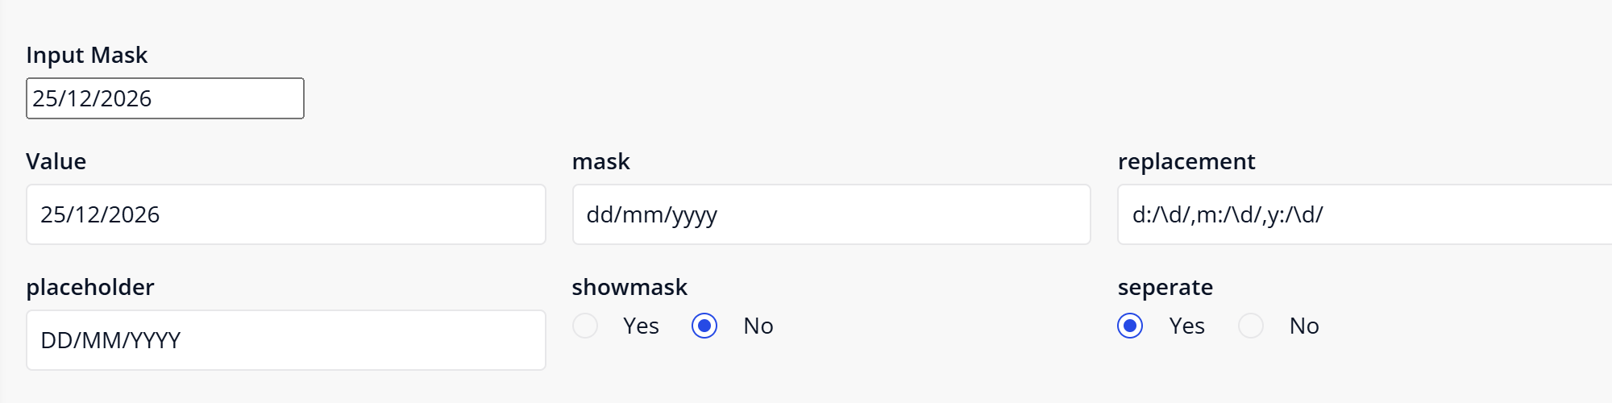
Figure 2. Date mask with three rules
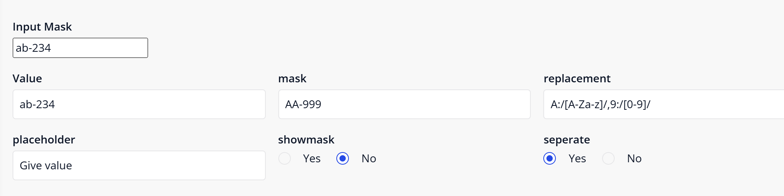
Figure 3. Mask with two rules: two letters, a hyphen, three digits

6. Property reference
All properties except the action are attributes of the context object. The text in brackets is the behaviour when no attribute is selected or the attribute is empty.
Property | Type | Description (when empty)
Value | String attribute, required | Stores the text exactly as shown in the input, including the fixed mask characters.
Mask | String attribute, required | The mask. (Nothing can be typed.)
Replacement | String attribute, required | The rules for the mask characters. (Nothing can be typed.)
Show Mask | Boolean attribute | True: the rest of the mask is shown while the user types. (false)
Separate | Boolean attribute | True: every typed character keeps its position; deleting a character in the middle leaves a gap. False: the characters after it shift to the left. (false)
Placeholder | String attribute | Text shown while the input is empty. ("Enter value")
Label, Editability, Visibility | Studio Pro settings | Work as for a text box. A read-only value attribute gives a disabled input.
On click action | Action | Runs when the user clicks the input.

7. Show mask and separate
With Show Mask true, the places that are not filled yet are shown with the mask character. The mask appears when the user types the first character; an empty input shows the placeholder.
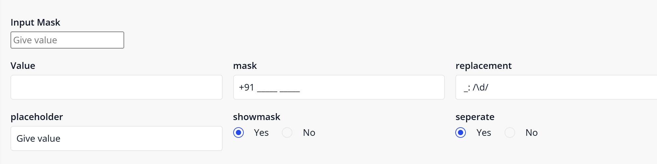
Figure 4. Empty input with the placeholder
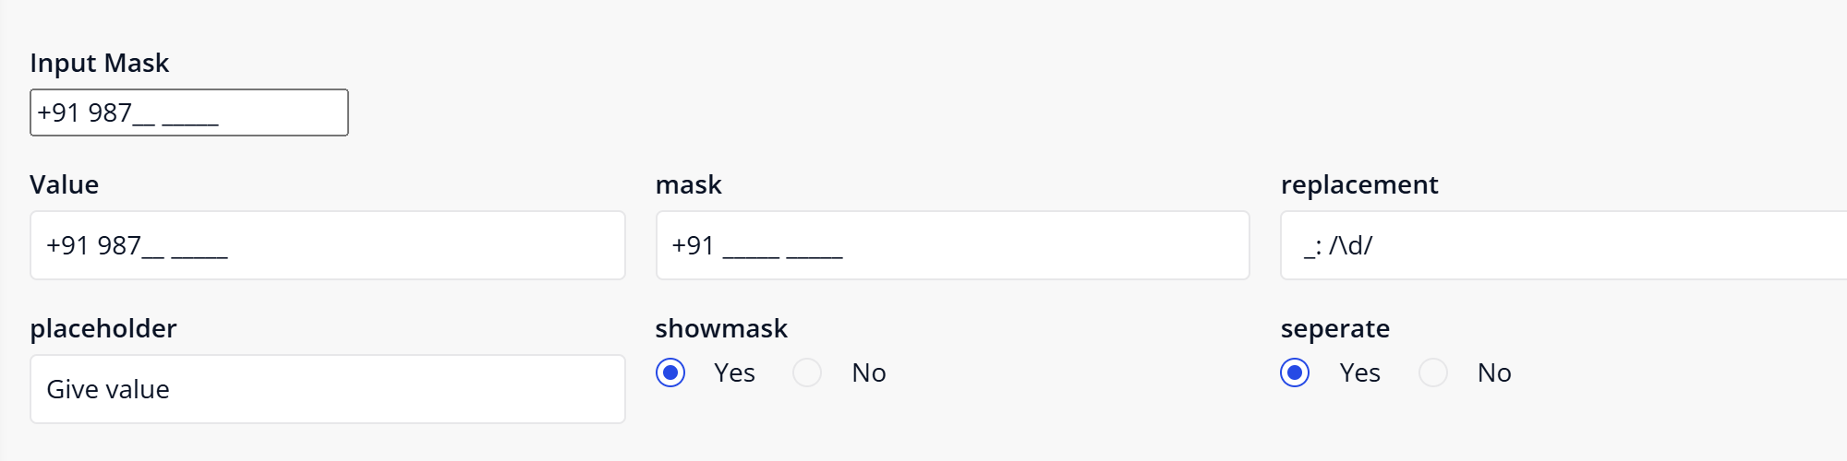
Figure 5. Show Mask true: the rest of the mask is visible
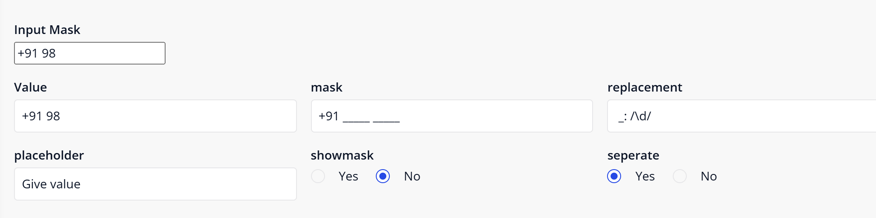
Figure 6. Show Mask false: only the typed part is shown
With Separate true, deleting a character in the middle leaves its place empty. With Separate false, the characters after it move to the left.
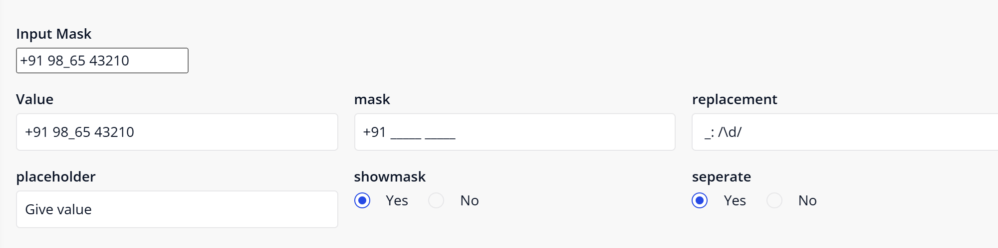
Figure 7. Separate true: the third digit was deleted and its place stays empty
The stored value contains the mask characters. With Show Mask true, a partly filled input is stored as +91 987__ _____, and an input where the user deleted everything is stored as +91 _____ _____. Check the value in your microflow before you use it.

8. Styling
The widget renders these elements inside the form group that Mendix creates for the label. The class and style from the Appearance tab are applied by Mendix to that form group.
<div class="form-group your-class">
<label class="control-label">Label</label>
<div class="widget-inputmask">
<input class="widget-inputmask-input">
<div class="alert alert-danger mx-validation-message"> validation message </div>
</div>
</div>
The input has the browser's own look, as in version 1.0.0. It does not have the Atlas form-control class. Example for your theme to make it look like the other inputs of the form:
.widget-inputmask-input {
width: 100%;
padding: 8px 12px;
border: 1px solid #ced0d3;
border-radius: 4px;
}
This example was not part of the test. When an On click action is set, the outer element also has the class widget-inputmask-clickable.

9. Known behaviour and limitations
- The settings are attributes. Static values cannot be typed in the widget properties; use attribute default values or set the values in a microflow or nanoflow.
- The widget needs a context object, so it must be inside a data view or list view.
- The value is stored with the fixed mask characters. The widget does not store a second value without them.
- A value that is set outside the widget is shown as it is. It is not reformatted to the mask; 9876543210 stays 9876543210.
- With an empty mask or an empty replacement nothing can be typed.
- With Show Mask true the mask appears when the first character is typed, not when the input gets the focus.
- The widget does not check that the mask is completely filled.
- The input does not use the Atlas input style (see chapter 8).
- Web only; not available in native mobile apps.

10. Support and version history
Report issues, suggestions and feature requests on GitHub:
https://github.com/bharathidas/InputMask/issues
Source code and all releases:
https://github.com/bharathidas/InputMask
Widget | Studio Pro | GitHub release | Changes
1.1.0 | 10.24.17 | Version1.1.0 | Rebuilt for Studio Pro 10.24.17; input can be cleared; commas and colons in regular expressions; invalid rules skipped; On click works; read-only and loading handled; validation message shown; label linked; design-mode preview.
1.0.0 | 10.24.6 | Version1.0.0 | First release.

